**PART V: Substrate setups**

1. **Substrate accounts: Set Substrate networks for your Polkadot-JS accounts.**

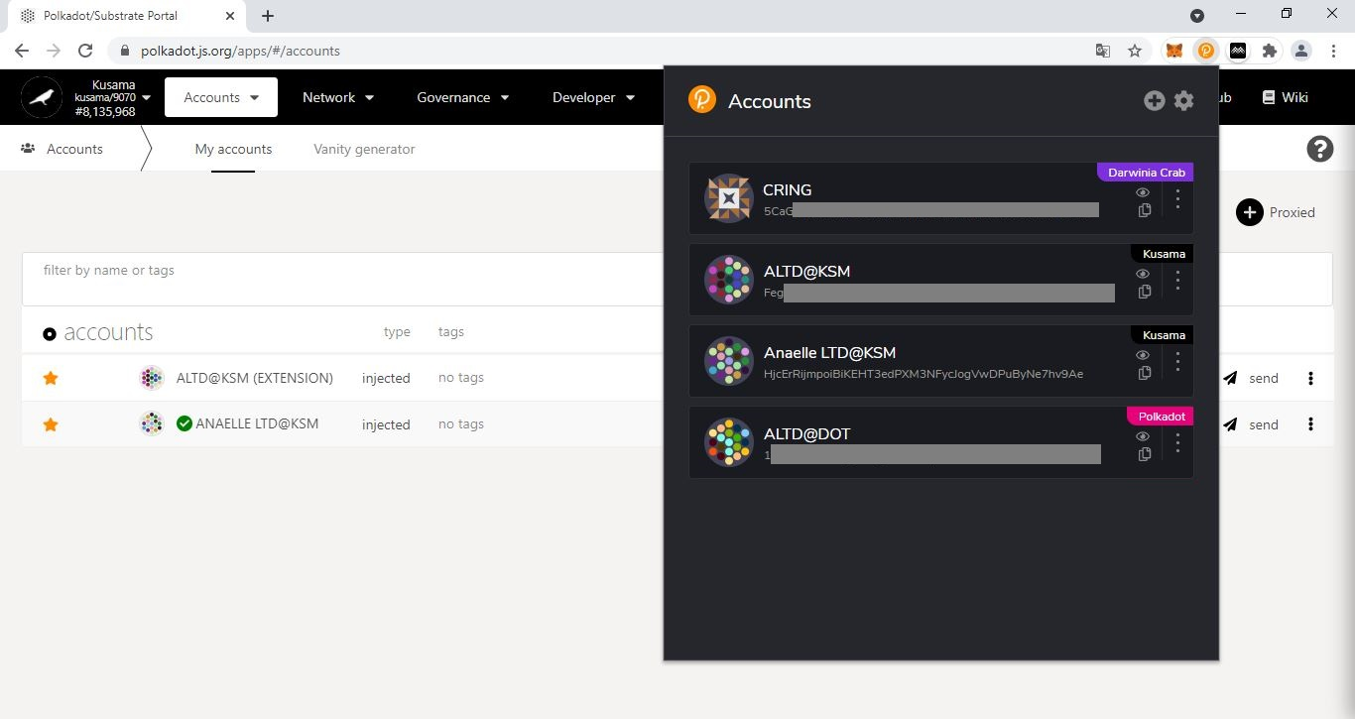

2. Click on the **3 vertical dots** to reveal the Account settings window.

1. Click on the **Polkadot-JS extension icon** to reveal the Accounts window.

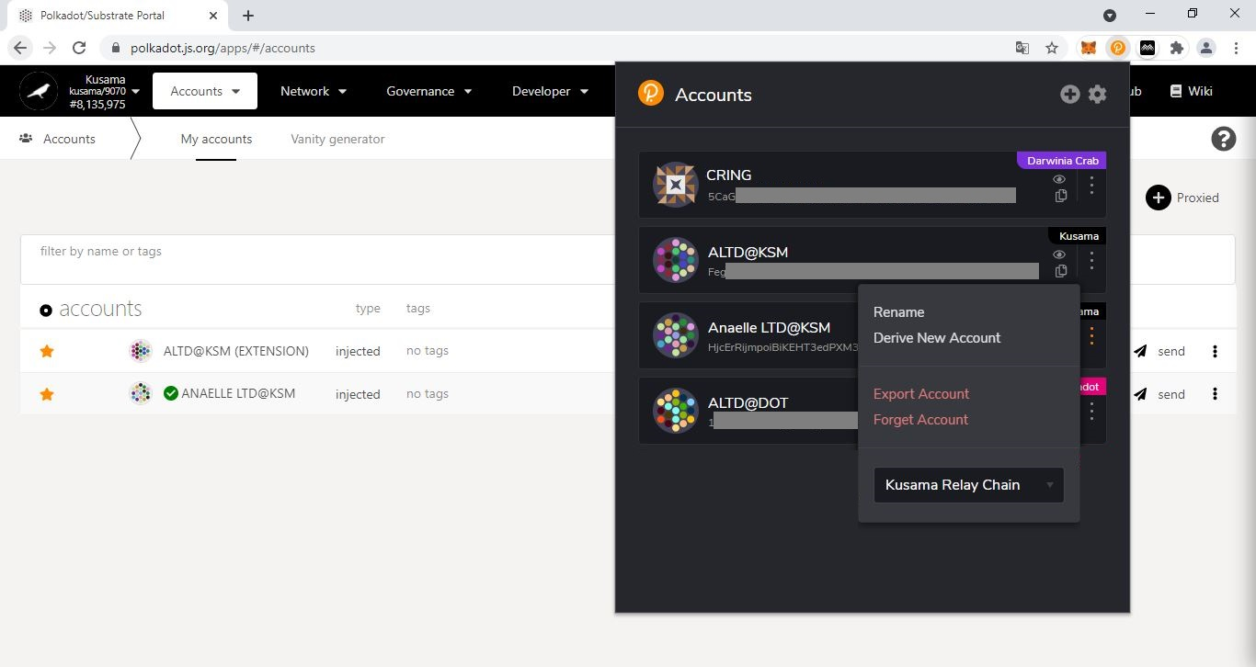

3. Click on the **dropdown arrow** to show the list of Substrate networks.

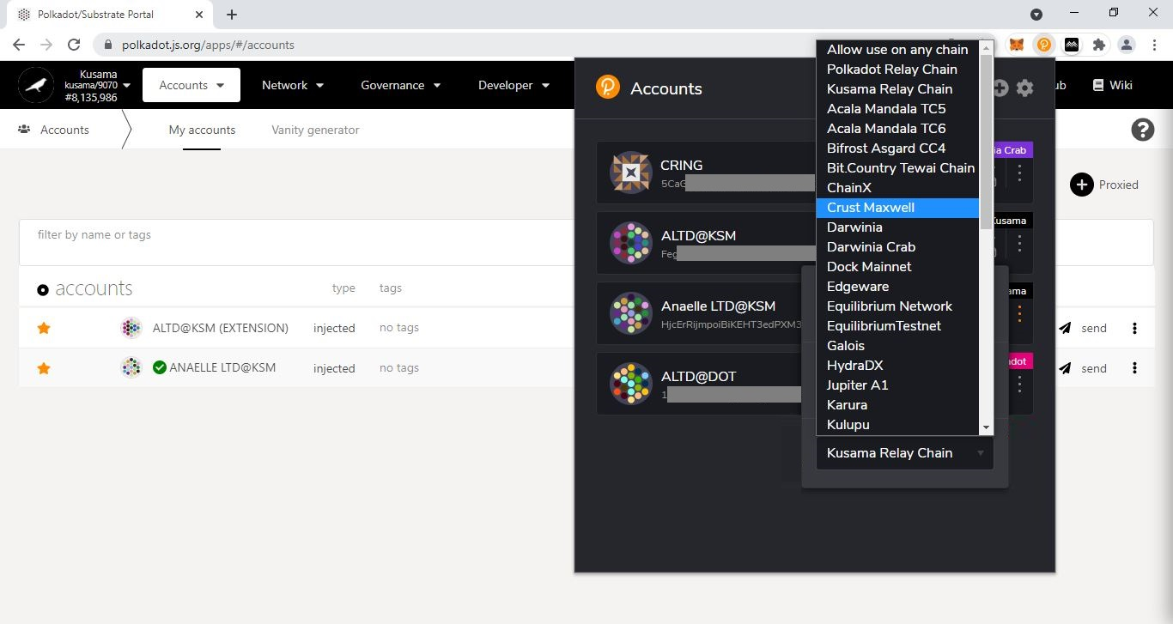

4. Select **one** Substrate network from the list or choose **Allow use on any chain** to access all Substrate networks.

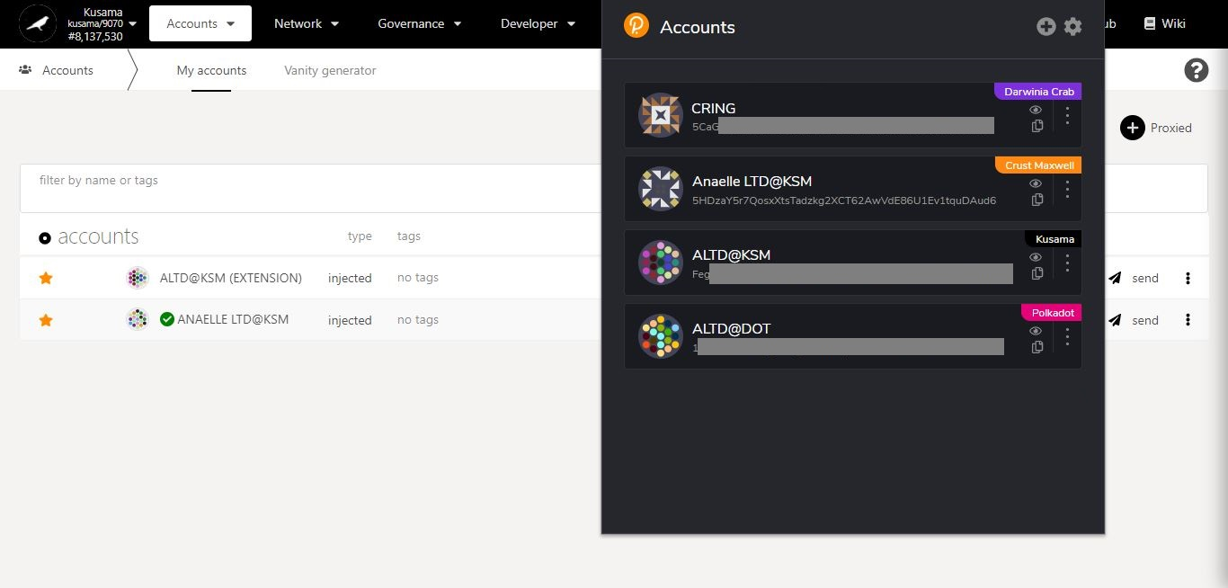

5. **Your account is now set up to access your chosen Substrate network**.

1. **Substrate chains: Switch between Relay chain/Parachain/Testnets’ interfaces.**

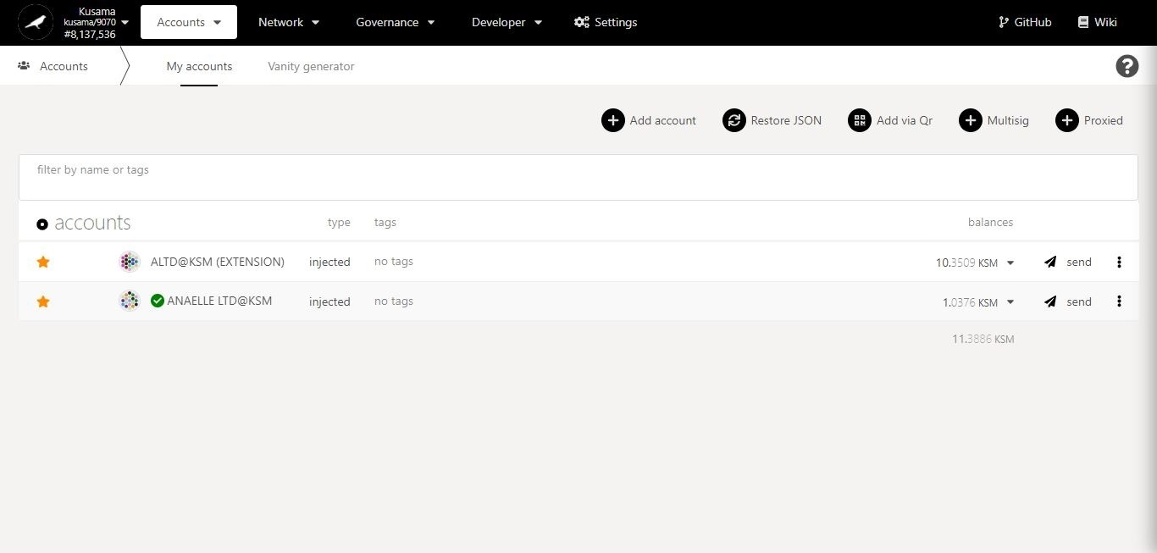

1. Click on the **dropdown arrow** to show the Substrate networks sidebar.

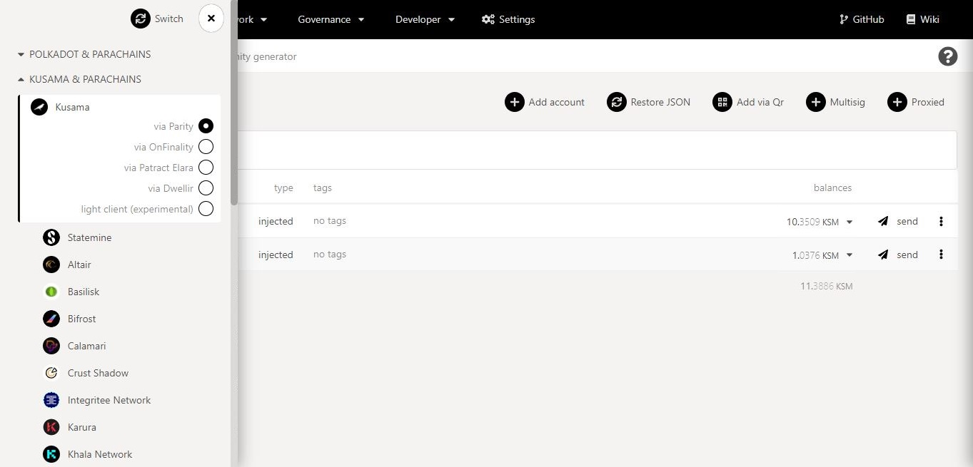

Substrate network nodes in detail:

All Substrate nodes expose endpoints for RPC connections across the network. **Any individual or organisation can run a (full or light) node for their selected network**, however Polkadot-JS Apps only feature a selection of reliable nodes.

You can connect to Relay chains:

**via Parity:** *Parity Technologies* is the company contracted by the Web3 Foundation to build Software Development Kits (SDKs) like ***Substrate*** and Parachain Development Kits (PDKs) like ***Cumulus***. These technologies power Relay chains (i.e ***Polkadot****,* ***Kusama***) and Parachains (i.e ***Karura****,* ***Moonriver****,* ***Shiden****,* ***Khala****,* ***Bifrost***, etc.).

**via OnFinality:** *OnFinality* is a leading infrastructure service for some of the largest blockchain projects.

**via Patract Elara:** *Elara* provides Polkadot developers with free, instant, and scalable blockchain API access services.

**via Dwellir:** *Dwellir* is an infrastructure provider for the decentralized web. It provides an RPC service with high resilience against DDOS and DNS unavailability.

**Light client:** A light client or light node does not sync or validate the full blockchain, yet still allows users to interact with the network in a trustless and secure manner. Note: Light clients play an essential role in the accessibility and usability of blockchain networks, as they can run on most mobile devices and still provide an optimal user experience.

You can connect to other Substrate chains via their respective network-specific nodes.

2. The sidebar displays your **current Substrate network and node**.

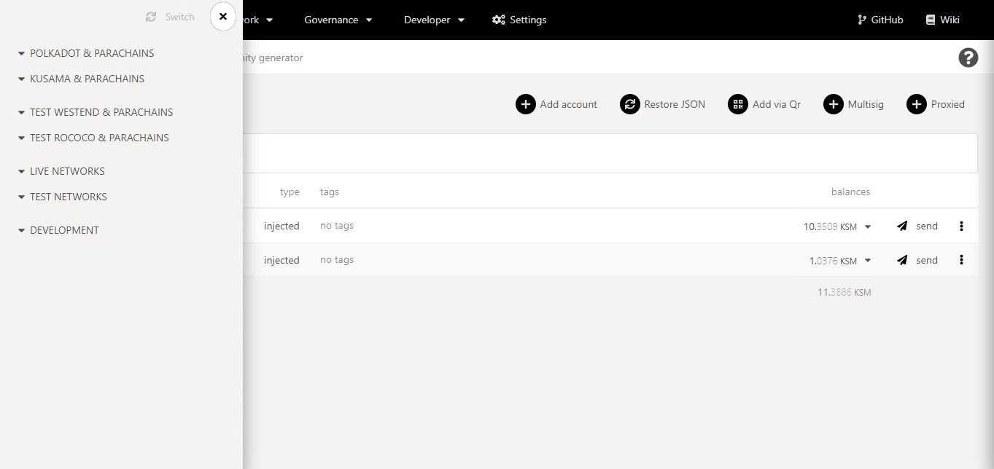

Substrate networks in detail:

**Polkadot & Parachains:** The Polkadot mainnet and all its live Parachains.

**Kusama & Parachains:** The Canary network and all its live Parachains.

Note: Substrate networks must obtain a Parachain slot (via auction bids or Council motions) to become live on Polkadot or Kusama.

**Test Westend & Parachains:** The testnet used for testing Relay chain-related technologies. It requires WND tokens for all its operations.

**Test Rococo & Parachains:** The testnet used for testing Parachain-related technologies. It requires ROC tokens for all its operations.

Note: Substrate networks must register a ParaID to participate in Parachain Slot auctions on Polkadot or Kusama.

**Live Networks:** Standalone Substrate chains that have deployed their mainnet.

**Test Networks:** Standalone Substrate chains that are preparing for mainnet deployment.

**Development:** Standalone Substrate playgrounds.



3. Navigate the sidebar dropdown menus to **find your chosen Substrate network.**

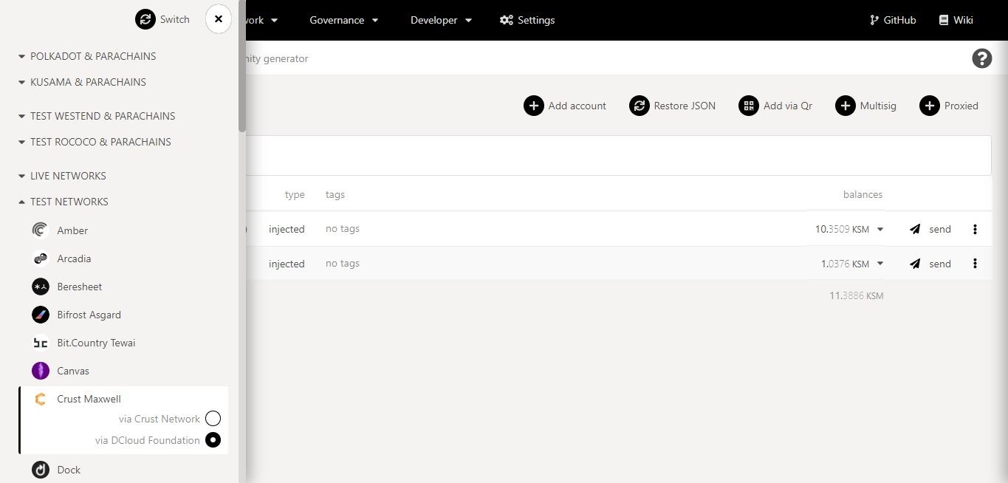

4. Select a **node** for your chosen Substrate network, then click on **Switch**.

5. **You have successfully switched Substrate network interfaces**!

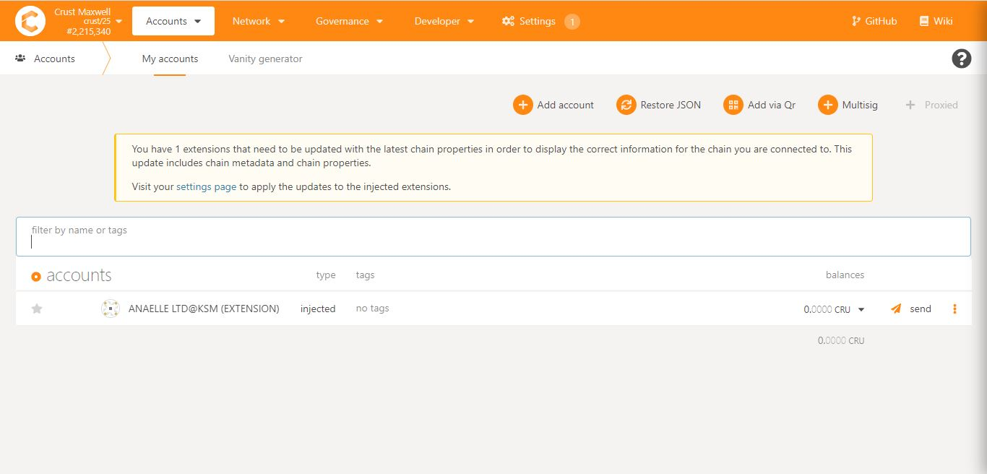

6. If prompted, update your **settings.**